**Loan Approval Risk Simulation   
for an Aging Population**  
  
*Explores how loan approval outcomes and financial risk evolve as the population ages*

MIHRET TESFAYE (LEAD)  
JOSHUA DAVIS

2025

**Project Title: Loan Approval Risk Simulation for an Aging Population**

1. **Project Overview**

Our project explores how loan approval outcomes and financial risk evolve as the population ages, especially focusing on individuals aged 50 to 70. Over a 50-year simulation horizon, we target to understand how borrower characteristics, approval policies, and economic conditions interrelate to influence loan profitability and default rates. The primary question we ask is: How will lending outcomes change for older borrowers as their population share increases over time?

We plan to use a Monte Carlo simulation to model individual borrowers and their outcomes under varying credit policies. In addition, we are exploring the integration of a risk scoring model to support more realistic decision-making.

1. **Simulation Objectives and Design**

We are building a simulation that reflects both borrower-level uncertainty (income, health, credit score) and macro-level changes (aging trend, market interest rates). The simulation is designed to model:

* Individual loan applicants with randomized demographics
* Loan approval decision based on default risk and policy thresholds
* Loan outcomes like default or repayment, and the resulting profit or loss.
* Annual cycles to simulate population shift over 50 years

Input Model

* Applicant variables: age, income, credit score, health status
* Market/Economic factors: interest rate
* Policy thresholds: default risk limits used to accept or deny applicants

Output

* Loan approval status
* Whether the loan defaulted
* Profit or loss from each loan
* Summary statistics over time

1. **Statistical and Simulation Framework**

|  |  |  |
| --- | --- | --- |
| Variable | Distribution Type | Explanation |
| Income | Normal | Simulated using a normal distribution centered around $40,000 with a standard deviation $5000 to reflect modest variation in applicant income levels |
| Expenses | Normal | Model using a normal distribution (mean=$25,000, SD=$4,000) to capture living costs and personal financial burden |
| Life Expectancy | Uniform | Drawn from a uniform distribution between ages 70 and 95. |
| Age (optional extension) | Normal (shift in mean) | It could be added later to model the aging population trend. This would allow the simulation of demographic change over time |

1. **Current Progress**

* Basic simulation function completed
* 50-year loop and full population simulation in progress
* Risk score logic under testing for realistic behavior
* Initial plotting underway

1. **Team Member Contributions**

Joshua Davis - Code initial framework design and testing

Mihret Tesfaye - Report drafting, research on demographic modeling, and testing

1. **Source Code**

For this project, the software is currently broken down into 4 source files:

*main.R* – Provides central execution and control of environment, simulation, and analysis

*inputs.R* – Origin of inputs for environmental variable sets and eventually data sources

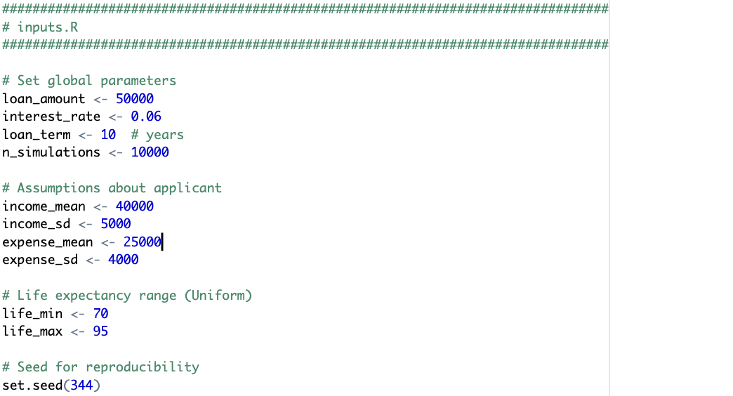

*monte_carlo_simulator.R* – Heart of the project where are all of the simulation will exist.

*output_analysis.R* – Lastly, the methods that will be used to provide analysis.

1. **References**

Doerr, S., Kabaş, G., & Ongena, S. (2024). *Population aging and bank risk-taking*. Journal of Financial and Quantitative Analysis. <https://doi.org/10.1017/S0022109023001011>

OpenAI. (2025). *ChatGPT: Language model (July 2025 version)* [Large language model]. <https://chat.openai.com>